COPYWRITING TRAINING AS A MEANS OF COMMUNICATION OF A BRAND AND A STRATEGY TO INCREASE SALES
(ON SOCIAL MEDIA INSTAGRAM)
Mukhtar Adinugroho, Rita Sari, Reizano Amri Rashid
Universitas Nahdlatul Ulama Surabaya
Jl. Raya Jemursari 51-57, Surabaya
E-mail: adi.msei2018@unusa.ac.id
Abstract
One of the successes of digital marketers is being able to maximize product and service promotion techniques using digital distribution channels such as websites, Adwords, email or various other social networks. One of the hopes of this training activity is that entrepreneurs who are just starting their business will be able to succeed in the business world where they must be equipped with good marketing skills. Seeing the importance of digital marketing, Copywriting training is needed for them. The method used is the psychological triggers approach. This activity is carried out online in the form of providing basic marketing theory, copywriting and advertising script writing training, so that the trainees are able to develop their businesses and businesses. This training activity was carried out for 1 day in the zoom application provided by BEM FEBTD (Faculty of Business Economics and Digital Technology) Nahdlatul Ulama University, Surabaya. The results of the activity showed that there was an increase in language skills and Copywriting of each participant where the ability that was most mastered by the average participant was an understanding of BFC (Basic Format Copywriting).
Keywords: Copywriting, Training, Digital Marketing, Basic Format Copywriting.
- Introduction
The existence of social distancing rules during the Covid-19 pandemic to break the chain of transmission of Covid-19 had a significant impact on the economy in Indonesia. According to the Central Statistics Agency (2020), 2.56 million people were recorded as unemployed due to the Covid-19 pandemic. The difficulty of finding a job amid the Covid-19 pandemic and social restrictions have made people more creative in seeking opportunities to improve the family economy. Evidently, now more and more business actors or entrepreneurs are emerging, both on a small, medium and large scale. This of course must get attention and support because the greater the number of entrepreneurs and the increasing business activity, economic independence can be achieved. Economic independence is one of the keys to national economic development. In digital society 4.0, many business actors or entrepreneurs have emerged who have utilized information technology (internet) to carry out their business/selling activities. Buying and selling activities carried out online are often referred to as electronic commerce (e-commerce). Online sites, social media, and marketplaces are widely used as marketing media so that product information reaches customers.
Basically, online sites, social media, and marketplaces have different customer characteristics. As a view, customers on Facebook prefer the hard selling method, namely a direct and clear sales approach in selling, directly inviting customers to buy their products. The hard selling method is usually also applied in online marketplaces. In contrast to the characteristics of customers on Instagram who do not like it when prospects buy products directly, so the soft selling method is more suitable for Instagram users. Soft selling is a sales approach with persuasive language.
The difference in the hard selling and soft selling methods can be seen from the writing/promotional text. Promotional writing/text used on Facebook or marketplaces tends to be aggressive, direct and clear, so they directly invite customers to buy products (hard selling). Meanwhile, promotional writing/text on Instagram can usually be in the form of informational writing, humorous writing, stories/chats that can keep customers curious so they continue to follow the seller's Instagram account (soft selling).
In writing interesting promotional text/writing on Instagram, a seller needs knowledge and skills in writing promotional text (copywriting). Copywriting itself can be understood as "a technique for creating marketing materials that can persuade customers to take the desired action, such as buying a product or service, subscribing to a newsletter, contacting sales, and so on."
There are various kinds of copywriting techniques. In this activity, the writer chooses one copywriting technique that will be explained, namely the formula about the psychological triggers copywriting technique.Psychological triggersis the ability of a copy to provide an emotional touch to target consumers to take action in accordance with advertising objectives. For example buying a product because our idol is the brand ambassador, or because the packaging is cute, and so on. You can use some of the following psychological prompts in a copy:
a. Curiosity
Arouse curiosity in consumers. For example, giving a teaser or lattice launching the latest product. By increasing this feeling, consumers will be encouraged to find out more, so that the possibility of taking action is also greater.
b. Promise
The copy that you make must be able to make consumers believe or trust the quality of the products being sold. For example, 5 year guarantee, money back guarantee, and more.
c. Hello effects
If you have a positive experience with a brand or product, you can also like other products from that brand. This is usually done with endorsements or the use of brand ambassadors. The positive image of a public figure can encourage followers to use similar products or services. For example, Skill Academy took Nicholas Saputra as an instructor for a photography class. Apart from the ability and experience that Nicholas Saputra has, the positive image he has encourages others to be enthusiastic about learning photography.
Unfortunately, many sellers, both through online buying and selling sites and social media, do not understand the science of copywriting, so many sellers feel that their sales are underdeveloped and do not reach the desired target. Therefore, this community service activity wants to try to overcome existing problems, namely by holding counseling on the importance of writing promotional text (copywriting) to increase online shop sales as an effort to revive the community's economy amid the Covid-19 pandemic. This community service activity was carried out by a Management lecturer at UNU Surabaya and in collaboration with BEM FEBTD-Unusa.
The target partners of this activity are women who own online shops on Instagram that sell food, clothing, skincare, and other women's products. The target partner was chosen because this activity was in collaboration with the Entrepreneurship Lecture (KWu) for management students where management students also provided counseling on the benefits of marketing through digital marketing. The purpose of this activity is to help online shop sellers to be able to increase their sales by being equipped with knowledge about copywriting. The method of implementation is online, namely zoom meetings, so it is hoped that it can reach more online sellers and can reduce direct interaction in order to break the chain of the spread of the Covid-19 virus.
- Literature Review
In order to understand more about this one writing activity, you can learn about its types. Each type has a different focus of action, which is as follows.
a. marketing
This type has a focus on product offerings by providing solutions to consumers. In addition, the writing will explain the benefits of the product. In other words, to attract and convince consumers to buy products at your location.
b. Direct Response
The function of this type of writing is to get an immediate response from the customer. For example, writing contains sentences inviting readers to choose CTA options, share content, subscribe to ebooks, and more. You can find this writing on homepages, search engine marketing ads, landing pages, and more.
c. seo
Search engine optimization aims to attract the attention of consumers. SEO copywriting has writing rules that must be followed. You can find it on the Google homepage from the answers to questions from the keywords written. Besides that, the writing is also used for landing pages, product categories and product descriptions.
d. Technical
For this type one explains the performance of a product and its services. The results of his writing can be found in technology, beauty, and health products. The content of the writing is very detailed with deep technical.
e. Brands
Brand copywriting is a writing technique used to explain brand identity as well as convey an image. Generally in the form of a brand tagline and slogan. Branding is often found in the "about us" section of logos and pages.
3. Research Design
In completing this research, researchers used a descriptive approach. That is, the data collected is not in the form of numerical data, but data derived from interview scripts, field notes, personal documents, notes or memos of researchers and other supporting official documents.
The purpose of using a qualitative approach is so that researchers can describe the empirical reality of the online shop phenomenon in the midst of the Covid-19 pandemic that has hit Indonesia. Consideration of researchers using this qualitative research as expressed by Lexy Moleong (2010: 138).
- Adapting qualitative methods is easier when dealing with multiple realities.
- This method presents directly the nature of the relationship between researchers and respondents.
- This method is more sensitive and adapts to the management of mutual influence on the value patterns encountered.
4. Results and Discussion
a. Activity Models
This activity was organized by a community service team who are management lecturers at Unusa (Nahdlatul Ulama University Surabaya) and in collaboration with several Unusa management students who also provided material in the form of counseling on the benefits of marketing through digital marketing. Counseling on copywriting techniques is carried out online through the zoom meeting application. The zoom meeting link is shown in figure 1. The purpose of this activity is to provide counseling to onlineshop owners on the importance of writing promotional text (copywriting) so that it is hoped that it can increase onlineshop sales amid the Covid-19 pandemic.
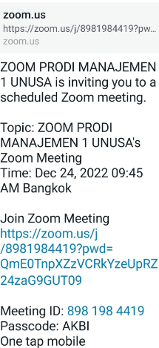
Figure 1.Zoom Meeting Link
The initial target for partners in this activity is 100 online shop owners on Instagram. Partners are limited to only 90 onlineshop owners because at the end of the event, partners participating in this activity are given souvenirs in the form of credit vouchers and the number of vouchers and partner targets are adjusted to the budget for this activity. In fact, the partners who wanted to take part in the event exceeded the initial target, so that in the end the partner's target quota was increased to 65 participants. The partners of this activity are women who own online shops on Instagram who sell food, clothing, skincare and other women's products from the island of Java. Most of the partners who took part in this activity came from several areas in East Java, such as Surabaya, Sidoarjo, Gresik, Tuban, Tulungagung, Madiun, Jember, Banyuwangi and several participants from West Java such as Bandung.
The counseling activity was held on Saturday, December 24 2022. The event started at 09.00 WIB, starting with the screening of the profile video of Universitas NU Surabaya. At 09.30 WIB, the MC read the opening remarks and procedures for conducting the webinar, then continued with a prayer and playing the Indonesia Raya anthem. The next program was the reading of the Curriculum Vitae of the instructor, namely the management lecturer at NU Surabaya University. At 10.00, the counseling delivered material on how to write promotional text (copywriting).
The tool used in this counseling is power point which contains copywriting material. After the presentation of the material, a question and answer session was held. In this session, the community service team gave door prizes to the 5 people who were the most active in asking questions and sharing their experiences when running an online shop. At the end of the event, participants were asked to fill out an evaluation form to find out to what extent the material presented by the instructor was understood by the webinar participants. The community service committee also gave souvenirs to all webinar participants who attended until the end of the event.
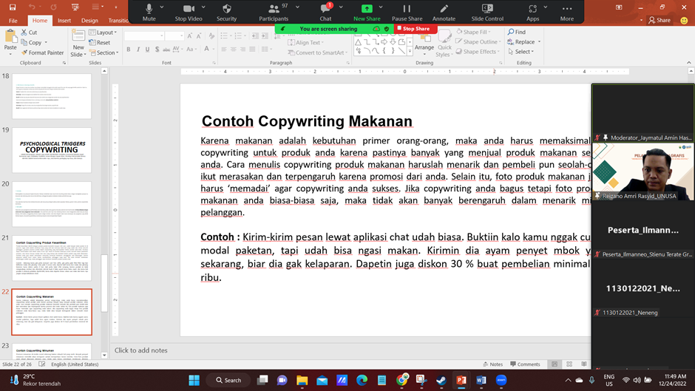

Figure 2.Presentation of copywriting material

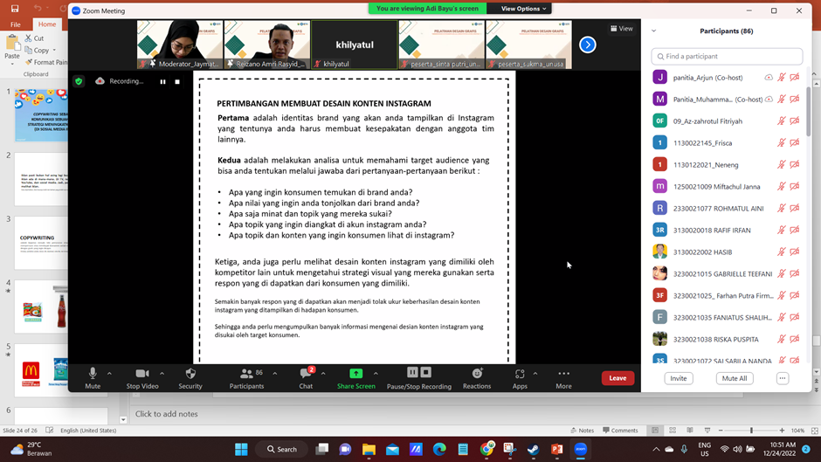

Figure 3.Copywriting trainee
b. Main Work
Before the webinar was held, the extension team conducted a survey of online shop marketing methods on Instagram and found that many online shops tended to only upload product photos, without writing promotional text. This happens for several reasons, including: 1) lack of understanding of promotional text writing techniques/copywriting techniques, 2) lack of confidence, 3) not being diligent in writing promotional texts. Therefore, a presentation of material on psychological triggers copywriting techniques was given. There are various kinds of techniques / formulas / formulas in making writing that sells. In this activity, the copywriting technique material discussed was the psychological triggers copywriting technique because it is easier to understand and more often used by online shops. Nevertheless,
The description of the material begins with distinguishing the caption (promotional text) used on Instagram and one of the marketplaces (shopee). After the participants were invited to discuss the differences and understood the differences, then the participants were introduced to the copywriting formula of psychological triggers copywriting. After being explained in detail, the instructor also gave examples of writing psychological triggers copywriting on Instagram that get high engagement, as evidenced by the large number of likes and comments from the post. The instructor also explained about copywriting technique material through telling stories.
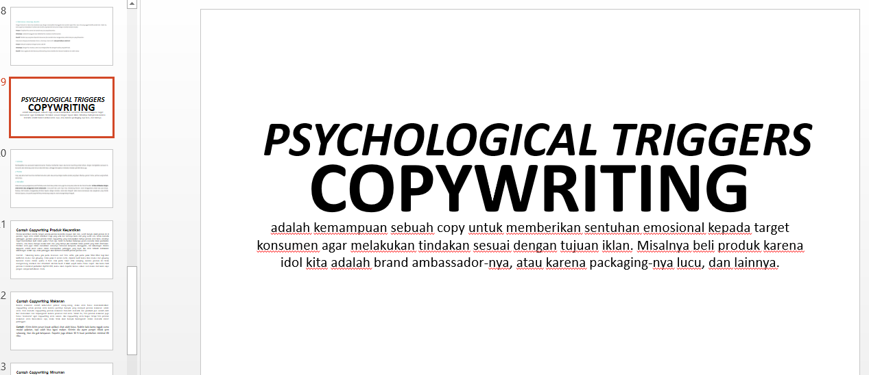
Figure 4.Copywriting material submitted.
In addition, extension workers also provide tips and tricks for writing promotional text if you don't find ideas to write about, including: Now you don't need to be insecure when taking selfies, you don't need to use filters anymore so that they look smooth and glowing. Try using X regularly, it's guaranteed that your skin will be really smooth and glowing in just X days. You don't need to be afraid of side effects, because this product doesn't contain mercury and added X fruit extract to make your face smooth fast. If you buy product X with a minimum purchase of IDR 150,000, you will get a bonus face wash from us. Come on, don't run out of stock (for beauty product copywriting). Sending messages via the chat application is commonplace. Prove that you don't only have to pay for packages, but you can already feed them. Send him chicken penyet mbok yem now, so he won't starve. Also get a 30% discount for a minimum purchase of 60 thousand (for copywriting food products). Confused looking for thirst quencher? It's time to try Havana Juice, today's fruit juice made from selected fresh fruit. Immediately return your spirit (for copywriting beverage products). Snapdragon 898, the fastest smartphone chip today. Comprehensive OLED display. Gorilla Glass 8 with four times better drop resistance. And Night mode on each camera (for gadget product copywriting). Gorilla Glass 8 with four times better drop resistance. And Night mode on each camera (for gadget product copywriting). Gorilla Glass 8 with four times better drop resistance. And Night mode on each camera (for gadget product copywriting).
c. Work Review
The survey that was conducted before the event started was limited to observations on each Instagram onlineshop, without any pre-survey form distribution. From the results of observations, it was found that several online shop product photos uploaded to the Instagram Feed were not accompanied by copywriting, so they were less able to attract customer attention to buy the products being sold or just follow their Instagram accounts. To attract customer interest and attention, successful copywriting text is one that can create the impression of curiosity, and make buyers not want to stop scrolling to read it. Therefore, captions must contain meaningful and useful information for onlineshop Instagram followers. The limited time for carrying out the webinar resulted in the provision of material still being limited in explanation of copywriting using the presentation method,
Even so, this webinar activity received good enthusiasm from the participants, as evidenced by the large number of participants who took part in discussing the state of the online shop being managed and the marketing techniques that had been carried out. One of the participants also asked about endorsement strategies besides doing copywriting techniques to increase Instagram engagement.
d. Impact and Benefit of Activities
This activity provides benefits to onlineshop owners, especially in the aspect of understanding and knowledge of onlineshop owners regarding copywriting. By participating in this activity, online shop owners can now understand and practice writing promotional text (copywriting) in Instagram captions. As a result, traffic on Instagram has increased due to increased engagement. In line with the increase in traffic, participants who took part in this activity claimed that there was an increase in sales and an expansion of the marketing network. Several participants also started to market their products to marketplaces, such as shopee, tokopedia and facebook marketplace.
5. Conclusion
Implementation of community service activities regarding copywriting is one of the efforts to help onlineshop owners and novice businessmen in increasing onlineshop sales amid the Covid-19 pandemic which was carried out by Management lecturers and undergraduate management students. By carrying out this activity, onlineshop owners and novice business people can better understand the importance of promotional text in Instagram captions and how to make promotional text in attractive Instagram captions. Writing Instagram captions provokes engagement from customers so that they can increase traffic. As a result, there was an increase in sales and an expansion of the online shop marketing network. With the significant results of increasing sales, further community service activities are needed, namely training in writing promotional texts.
Aknowledgment
Thanks are addressed to Nahdlatul Ulama University in Surabaya for funding this Community Service Activity under the Internal Community Service scheme. Also, we would like to thank BEM-FEBTD (Faculty of Business Economics and Digital Technology) for supporting this event to the end. We thank the community service team who have given their time, thoughts, and energy to continue this training event.
Bibliography
1. Hukumonline.com, “Government Regulation No. 21 of 2020 concerning Large-Scale National Restrictions,” vol. 2019, pp. 1–5, 2020.
2. RH Sayuti, D. Siti, and A. Hidayati, "The Impact of the Covid-19 Pandemic on the Community's Economy in West Nusa Tenggara," RESIPROKAL J. Ris. social. Actual Progressive, vol. 2, no. 2, pp. 133–150, Dec. 2020, doi: 10.29303/RESIPROKAL.V2I2.46.
3. BPS, "Indonesian Employment Conditions August 2019," Pus Agency. Stat., vol. XXiI, 05 N, no. 91, pp. 1–20, 2019, Accessed: Nov. 22, 2021. [Online]. Available: https://www.bps.go.id/publication/download.html?nrbvfeve=YjdlNmNkNDBhYW VhMDJiYjZkODlhODI4&xzmn=aHR0cHM6Ly93d3cuYnBzLmdvLmlkL3B1Ymx pY2F0aW9uLzIwMTgvMDYvMDQvYjdlNmNkNDBhYWVhMDJiYjZkODlhODI 4L2tlYWRhYW4tYW5na2F0YW4ta2VyamEtZGktaW5kb25lc2lhLWZlYnJ1YXJp LTIwMTgu. 4. B. Triatmanto, A. Sanusi, and DA Siswati, "Strategy to Maintain Business and Increase Community Role during the Covid-19 pandemic in the Batik Zheng Community Economic Empowerment Activities," JAST J. Apl. Science and Technology., vol. 4, no. 2, pp. 142–152, Jan. 2021, doi: 10.33366/jast.v4i2.2063.
5. D. Susandi and S. Sukisno, "E-Commerce Based Sales System Using Object Oriented Methods on Dlapak Street Wear Distro," JSiI (Journal of Information Systems), vol. 4, pp. 5–8, 2017, doi: 10.30656/jsii.v4i0.368.
6. “The Difference between Hard Selling and Soft Selling - Akudigital.” https://www.akudigital.com/bisnis-tips/perbedaan-hard-selling-dan-soft-selling/ (accessed Aug. 13, 2021).
7. “AIDA Formula for Writing in Copywriting - Articles | Digital Campus.” https://campusdigital.id/artikel/formula-aida-untuk-menulis-dalamcopywriting?ref=farisfanani (accessed Aug. 20, 2021).
8. “(PDF) Measuring soft-sell versus hard-sell advertising appeals.” https://www.researchgate.net/publication/259834596_Measuring_softsell_versus_hard sell_advertising_appeals (accessed Aug. 30, 2021

